**1. INTRODUCTION**

1.1 OVERVIEW

In this project shows that the analysis of the Indian agricultural crop production from 1997 – 2021 and many ideas for improve the agriculture in India.

1.2. PURPOSE

Through this project we can understand and to implement of agriculture.

Also, to convey about the agriculture to youngsters.

**2. PROBLEM DEFINITION & DESIGNING THINKING**

2.1 Empathy Map

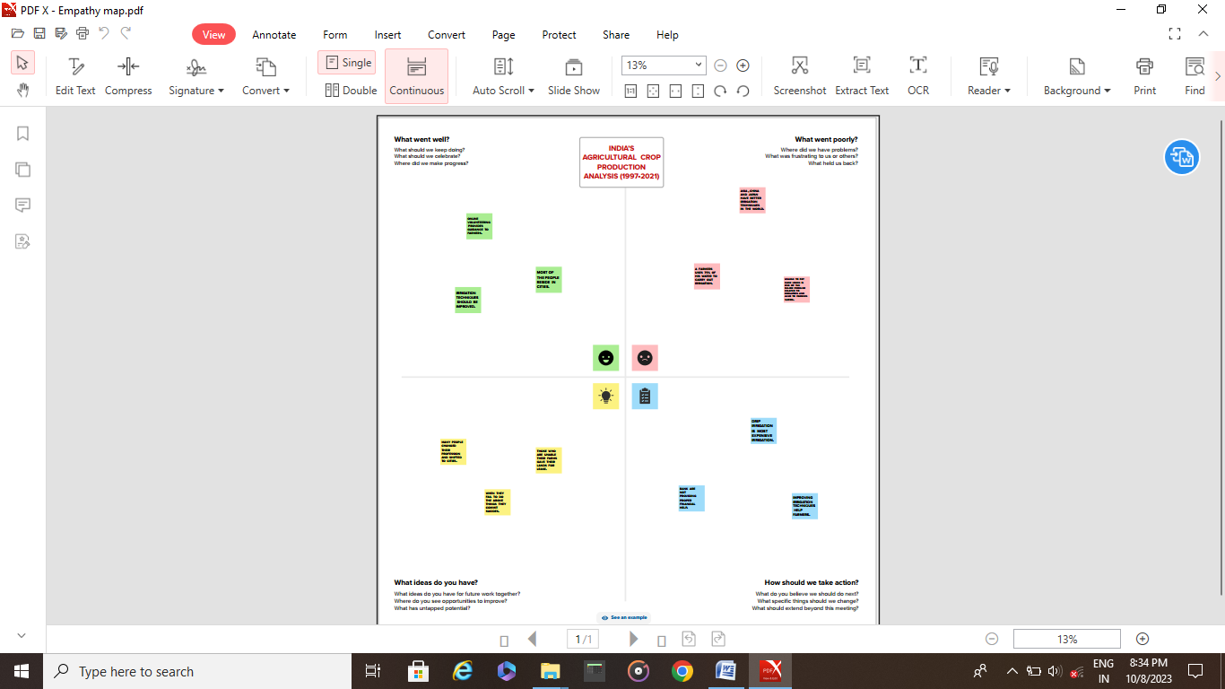

2.2 Ideation & Brainstorming Map

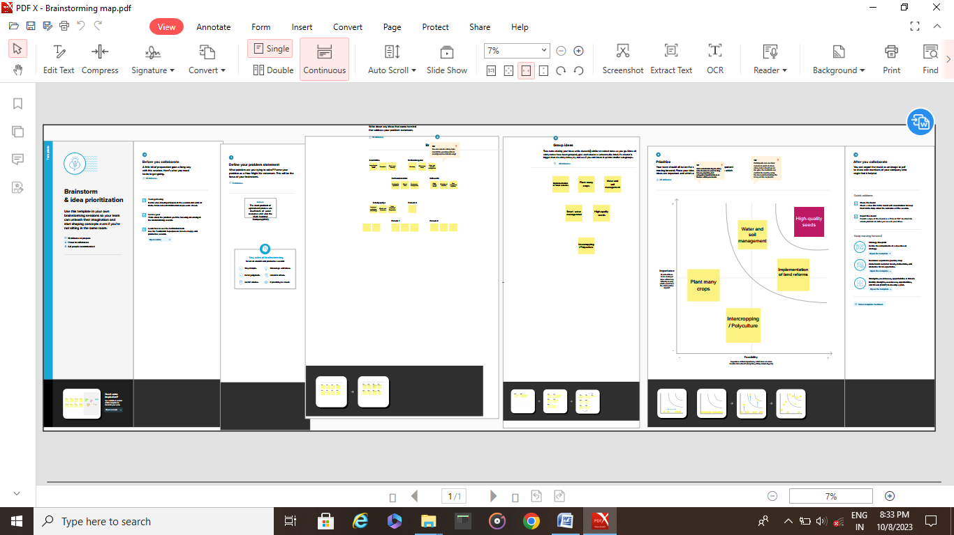

**3.RRESULT**

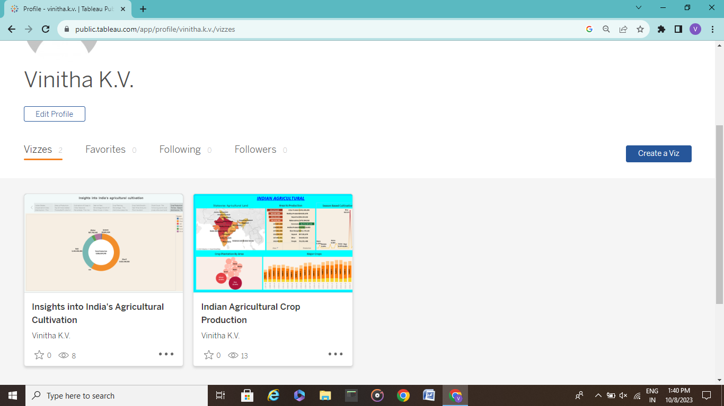

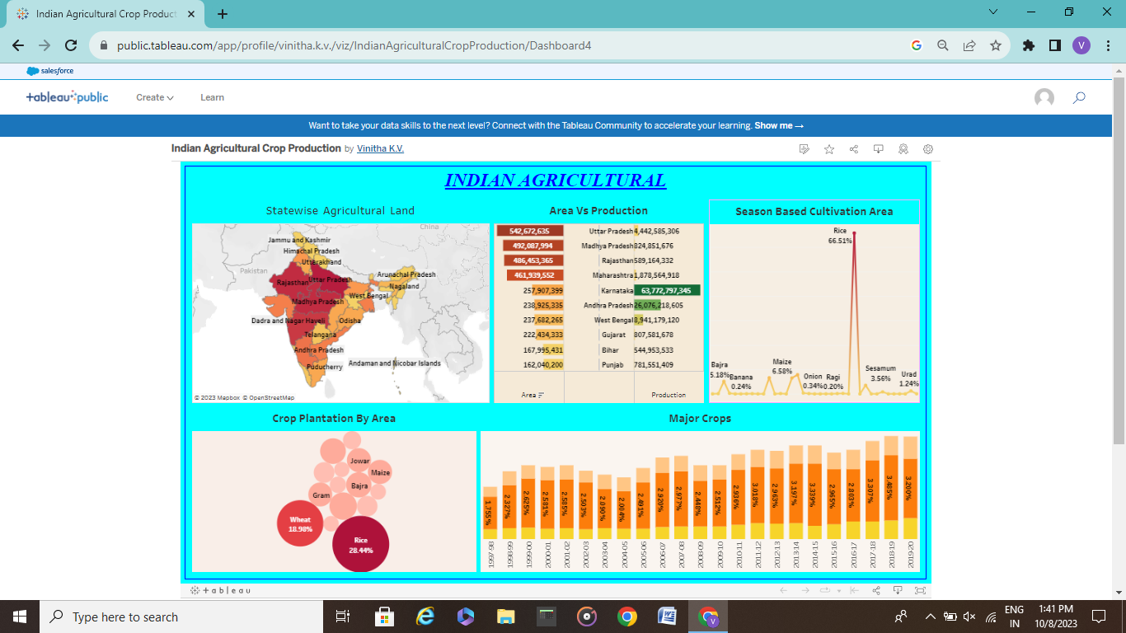

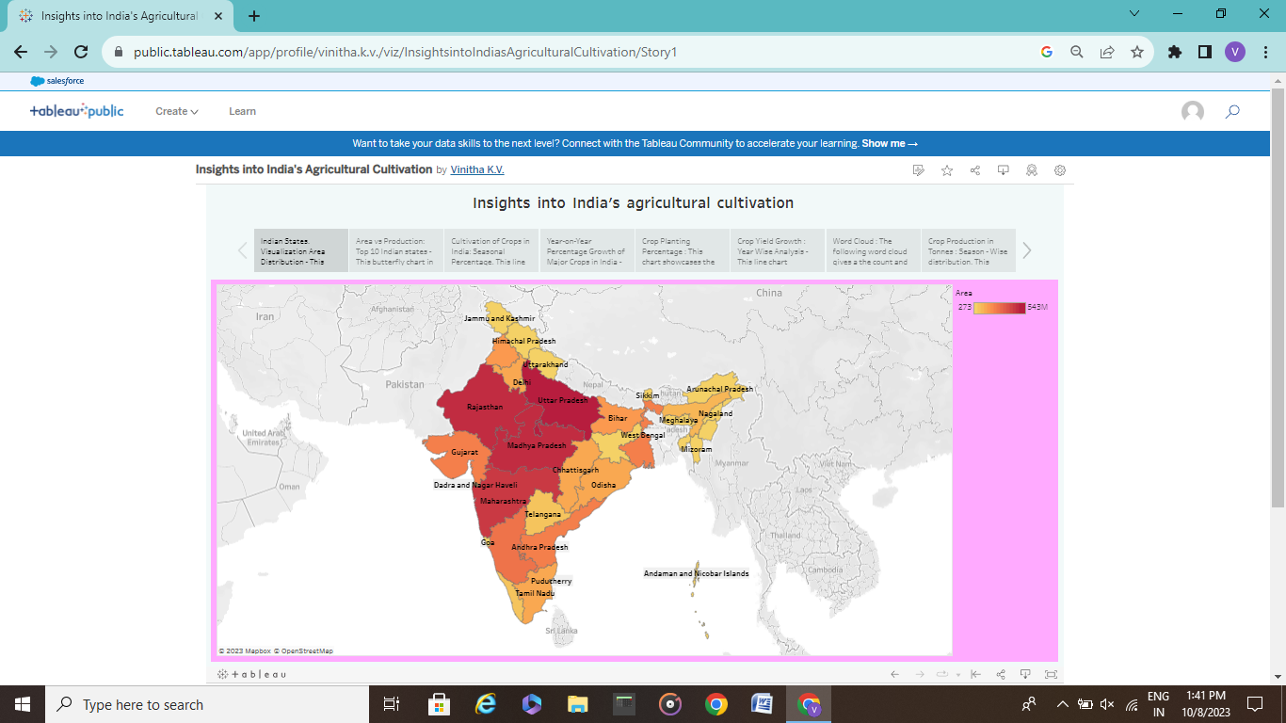

**4. ADVANTAGE & DISADVANTAGE**

* Thisproject’s advantage is thatensure the profitability of their land while improving soil fertility, helping promote sound environmental practices.
* An another advantage is to minimizing environmental impacts through climate action. Climate change regulation.
* This project’s disadvantage is that the deforestation and Alteration of The Natural Environment.

**5. APPLICATIONS**

This solution are applied of this project is about improvementing the agriculture crop production.

**6. CONCLUSION**

In my ideas the conclusion of this project is about the development or improving the agriculture in India and also this are convey to the farmers is to their knowledge to understand o make new methods.

**7.FUTURE SCOPE**

I want to say the final words of this project that the project’s ideas or thinking or thoughts are convey to farmers to their knowledge is also used for them and their next generation.